27.Design TM using a simulator to accept the input string wcw .

AIM: To design TM using a simulator to accept the input string wcw.

TRANSITION DIAGRAM:

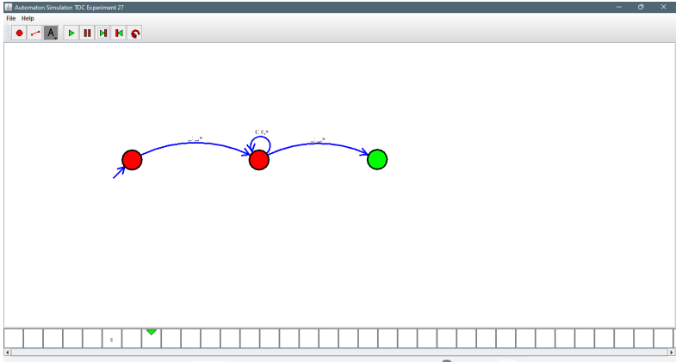

**RESULT:** Hence designing TM accepting the input string wcw